AUTHOR

|  |  |  |  |  |  |  |
| --- | --- | --- | --- | --- | --- | --- |
| **Department** |  | **Signature** |  | **Print Name** |  | **Date** |
| R&D |  |  |  | Douglas Tenney |  |  |

SIGNATURES

|  |  |  |  |  |  |  |
| --- | --- | --- | --- | --- | --- | --- |
| **Department** |  | **Signature** |  | **Print Name** |  | **Date** |
| R&D |  |  |  |  |  |  |
| Quality |  |  |  |  |  |  |

Revision History

|  |  |  |  |  |  |  |
| --- | --- | --- | --- | --- | --- | --- |
| **Rev.** |  | **Date** |  | **Initials** |  | **Description** |
| A |  | 16-Oct-2009 |  | DAT |  | Initial Release |
| A.1 |  | 06-Feb-2019 |  | DAT |  | Update Format, Add INTELLIO Link |
| A.2 |  | 27-Aug-2019 |  | DAT |  | Add Serial Number storage. Record / report the number of times a system has been powered on and a handpiece activated. Update Non-volatile memory. Remove obsolete Powered Instrument accessories, Update Link Icon to WIFI transmitter. Added alarm cycling variance ± 5%, Generate Handpiece Sensor Fault if Handpiece controls lost while MDU is running |
| B |  | 24-Sep-2019 |  | DAT |  | Updated to Revision B |
| C |  | 19-Jan-2021 |  | DAT |  | Reduce supported Footswitches to DYONICS POWER II Footswitch 72201092 and Pedal Style 7205396  Reduce supported Power Instrument handpiece support to Pistol Grip Drill 7205785 and Inline Sagittal Saw 7205786  Remove 7205971 UltraLight  Remove CAN testing for 11800157  Update company logo and copyright  Clarify Handpiece serial number length up to 11 characters |

Glossary

SC – System Controller

MC – Motor Controller

GUI – Graphical User Interface

DLL – Dynamic Link Library

MDU – Motor Drive Unit

Handpiece – MDU, Saw or Drill

Port A – Handpiece A Interface

Port B – Handpiece B Interface

Framework – MFC framework

Distal – Furthest from surgeon as held (blade end)

Proximal – Nearest to surgeon as held (cord end)

References

15000283 – DYONICS II Footswitch Software Requirements Specification

15000285 – Shaver Pump Interface Protocol

15000286 – DYONICS II RS485 Accessory Protocol

15000695 – DYONICS POWER II System Controller Software Requirements Specification

15000701 – DII EIP Motor Controller Software Requirements Specification

15000702 – Motor Controller Software Design Specification

15000721 – DYONICS II EIP Inter Controller Protocol

15000768 – DYONICS II EIP Software Upgrade and Repair Specification

15007915 – DYONICS POWER II INTELLIO Link Protocol

Table of Contents

[1 Overview 4](#_Toc61967711)

[2 Software Design Specification 4](#_Toc61967712)

[2.1 System Interfaces 4](#_Toc61967713)

[2.1.1 Boot Interface 4](#_Toc61967714)

[2.1.2 Software Upgrade Interface 5](#_Toc61967715)

[2.1.3 Serial Port Interfaces 6](#_Toc61967716)

[2.1.4 Display Interface 6](#_Toc61967717)

[2.1.5 Touch Screen Interface 6](#_Toc61967718)

[2.1.6 Motor Controller Interface 6](#_Toc61967719)

[2.1.7 Non-volatile Storage Interface 6](#_Toc61967720)

[2.2 Controlling Application 7](#_Toc61967721)

[2.2.1 Icons 7](#_Toc61967722)

[2.2.2 INTELLIO Link Interface 8](#_Toc61967723)

[2.2.3 Shaver Pump Interface 9](#_Toc61967724)

[2.2.4 Operational Screens and Conditions 10](#_Toc61967725)

[2.2.4.1 MDU 11](#_Toc61967726)

[2.2.4.2 Powered Instrument 15](#_Toc61967727)

[2.2.4.3 Oscillate Modes 16](#_Toc61967728)

[2.2.4.4 Footswitch 17](#_Toc61967729)

[2.2.4.5 Warnings / Faults 17](#_Toc61967730)

[2.2.5 Settings Screens 22](#_Toc61967731)

[2.2.5.1 Blade Reset 23](#_Toc61967732)

[2.2.5.2 Blade Recall / Blade Default Mode 23](#_Toc61967733)

[2.2.5.3 Oscillate Modes 23](#_Toc61967734)

[2.2.5.4 Footswitch 25](#_Toc61967735)

[2.2.5.5 Pump Interface 25](#_Toc61967736)

[2.2.5.6 System Information 26](#_Toc61967737)

[2.2.5.7 Language 27](#_Toc61967738)

[2.2.6 Board and System Tests 28](#_Toc61967739)

System Controller Software Design Specification

# Overview

The System Controller (SC) shall be a primary element in an arthroscopic powered resection design that is responsible for controlling two low voltage DC motors. The System Controller shall communicate control and parametric data bi-directionally with a Motor Controller (MC). Using a set of System Interfaces a Controlling Application shall provide a user with graphical status and touch screen control over the motor operation. It shall also optionally provide status to a DYONICS 25 Fluid Management System and status signals to and control signals from the INTELLIO Link.

# Software Design Specification

The software design of the System Controller is divided into two major sections, the System Interfaces and the Controlling Application.

## System Interfaces

The System Interfaces are hardware initialization and access functions to resources of the System Controller used by the Controlling Application. The System Interfaces consist of a Bootstrap for Windows CE 5.0, peripheral Windows CE device drivers provided by Adeneo Embedded and a Windows CE device driver developed internally by Smith & Nephew.

### Boot Interface

1. The Boot Interface is divided into four sections of the on board FLASH. The first section is the SC Boot FLASH. The second section is the Set Speed FLASH. The third section is the lower copy of the SC Image FLASH. The fourth section is the upper copy of the SC Image FLASH.

Lower Image FLASH

Upper Image FLASH

Boot FLASH

Boot FLASH

0x11000000

0x10000000

0x10880000

0x10100000

Set Speed FLASH

Boot FLASH

0x100C0000

Both the lower and upper SC Image FLASH is created by the Software Upgrade Interface. Upon powering up the SC the Boot software will initialize the MCU and relocate the Boot FLASH to SRAM. Running from the SRAM the bootstrap will CRC the lower and upper SC Image FLASH. If both the lower and upper fail the CRC, the bootstrap will enable the buzzer and loop forever.

1. If either the lower SC Image FLASH passes the CRC or the upper SC Image FLASH passes the CRC, the bootstrap will then initialize the display and load Splash Screen from the SC Image FLASH. The Splash screen will display the Smith & Nephew Logo, Product Name and Software Version. The bootstrap will now load the Windows CE kernel image from SC Image FLASH into SRAM and start the Windows CE kernel boot.

### Software Upgrade Interface

1. The Software Upgrade Interface uses the Adeneo Embedded AT91SAM9263 USB driver to provide USB flash drive support for Windows CE. The Software Upgrade process starts by checking the status of the Boot Interface CRC of the lower and upper SC Image FLASH. If the lower SC Image FLASH has a valid CRC but the upper SC Image FLASH does not, then the lower SC Image FLASH is copied to the upper SC Image FLASH. If the upper SC Image FLASH has a valid CRC but the lower SC Image FLASH does not, then the upper SC Image FLASH is copied to the lower SC Image FLASH.

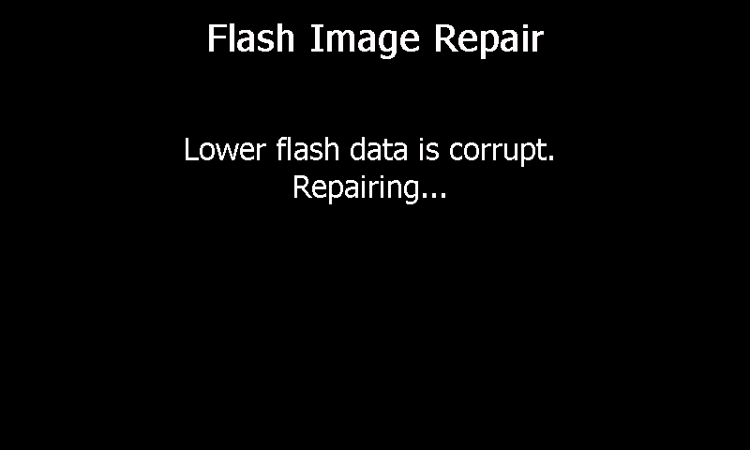

If both the lower and upper SC Image FLASH failed the CRC or any errors were encountered during the copying of the SC Image FLASH, the Software Upgrade process will report an error and stop. Otherwise for 3 seconds, the Software Upgrade process will then scan for an upgrade file on a USB flash drive inserted into the external USB port. If an upgrade file is found the Software Upgrade process will read in the upgrade file from the USB flash drive. If the upgrade file contains a SC Image that passes a CRC, it will display the current version and proposed upgrade version of the SC Image. If the upgrade file contains an MC Image that passes a CRC, it will display the current version and proposed upgrade version of the MC Image. Then it will prompt the user to Start or Cancel the upgrade. If Cancel is selected the upgrade will not take place.

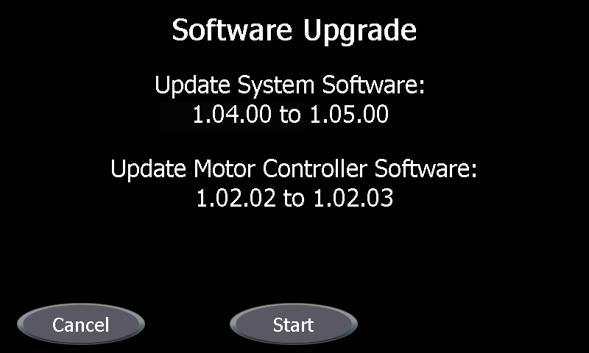

If Start is selected, the Software Upgrade process will copy the SC Image into the lower SC Image FLASH and the upper SC Image FLASH.

1. There are always two copies of the SC Image FLASH, (both upper and lower), and the Software Upgrade process updates them one at a time starting with the lower SC Image FLASH. If the upgrading of the lower SC Image FLASH is interrupted, the next Boot will use the upper SC Image FLASH and repair the lower SC Image FLASH. If the upgrading of the upper SC Image FLASH is interrupted, the next Boot will use the lower SC Image FLASH and repair the upper SC Image FLASH. In either case the SC will always be able to Boot.

### Serial Port Interfaces

The Serial Port Interfaces use the Adeneo Embedded AT91SAM9263 serial driver. The driver allows use of Windows CE serial port control functions for three serial ports.

1. The serial port COM3: is used for INTELLIO Link communication.
2. The serial port COM2: is used for Shaver Pump communication.
3. The serial port COM4: is available for future communication.

### Display Interface

The Display Interface uses the Adeneo Embedded AT91SAM9263\_LCDC display driver. The driver provides an 800x480 pixel color LCD display and allows use of Windows CE graphic functions for use by the Controlling Application.

### Touch Screen Interface

The Touch Screen Interface uses the Adeneo Embedded AT91SAM9263 touch screen driver. The driver provides the frame work with positional data for the Controlling Application button control.

### Motor Controller Interface

The Motor Controller Interface uses the Smith & Nephew driver to communicate to a Motor Controller via an Inter Controller interface. It provides the System Controller Application with the ability to read and write variable length word functions to communicate with the MC through its control register interface. The protocol specification for the Inter Controller interface is contained in the document Dyonics II EIP Inter Controller Protocol (15000721). The MC behavior is specified in the Motor Controller Software Design Specification (15000702).

### Non-volatile Storage Interface

The Non-volatile Storage Interface uses the Smith & Nephew driver. The Interface provides the Controlling Application functions for reading and writing the battery backed up Non Volatile RAM on the board. The Interface also provides read, write and erase functions for the on board SC FLASH.

1. The System Controller uses the interface to the battery backed up non-volatile RAM storage for the Setting Screens.
2. The System Controller uses the non-volatile interface to FLASH storage for the Boot Interface.
3. The System Controller uses the non-volatile interface to FLASH storage for the Software Upgrade Interface.
4. The System Controller uses the non-volatile interface to FLASH storage for Blade Recall Mode.
5. The System Controller uses the non-volatile interface to FLASH storage for Serial Number of the DYONICS POWER II.
6. The System Controller uses the non-volatile interface to FLASH storage for recording the number of times the DYONICS POWER II has been powered on and a handpiece activated.

## Controlling Application

The controlling application is a single process, multi-threaded, event driven application which utilizes C++, Windows Messaging, MFC and Win32. The operating system is Windows CE 5.0. The architecture consists of three modules. The first is the Graphical User Interface (GUI), the second is the Control Module and the third is the String Resource Module. The modular architecture can be represented diagrammatically as follows:



The GUI module is responsible for all graphical display of data, widgets and widget control. The control module is responsible for initialization and control of the MC along with the monitoring of status. The control module is also responsible for notifying the GUI of a change in state. The String Resource module is a Dynamic Link Library (DLL) that is responsible for supplying the GUI with the correct strings depending on what the selected language is. Each supported language has its own resource DLL which gets loaded at power up or if the language selection found in the Settings menus is changed. The System Interface is responsible for all interaction with the MC.

### Icons

1. Upon notification, from the control module, of a DYONICS 25 Fluid Management System connection or a pump connection from the DYONICS POWER II INTELLIO Link Protocol the GUI module displays an impeller bitmap ImpellerGray above Port A or Port B depending on the mapping selected in the Settings menus. If the GUI receives a disconnect notification the impeller bitmap is removed from the screen. If the connected pump supports notification of the pump state, the control module will notify the GUI. If the notification signals that the pump is running the GUI displays and animates a blue impeller bitmap ImpellerBlue otherwise the GUI displays the stationary gray impeller bitmap ImpellerGray .
2. Upon notification from the control module of a INTELLIO Link connection, the GUI module displays a INTELLIO Link bitmap D:\VSS\R_D\DII-EIP\Software\Applications\Shaver\Graphics\IntellioLinkIcon.bmp in the upper right hand corner of the screen. If the GUI receives a disconnect notification the INTELLIO Link bitmap is removed from the screen.
3. Upon notification from the control module of the insertion of a footswitch, the GUI module displays a blue footswitch bitmap above Port A FootPedalPortA or a yellow footswitch bitmap above Port B FootPedalPortB depending on the mapping selected in the Settings menus. If the GUI receives a disconnect notification the footswitch bitmap is removed from the screen.
4. Upon notification from the control module of the insertion of an MDU in Port A, the GUI module displays a blue MDU bitmap ShaverPortA above Port A. If the GUI receives a disconnect notification for Port A, the MDU bitmap is removed from the screen. Upon notification, from the control module, of the insertion of an MDU in Port B the GUI module displays a yellow MDU bitmap ShaverPortB above Port B. If the GUI receives a disconnect notification for Port B the MDU bitmap is removed from the screen.
5. Upon notification from the control module of the insertion of a Saw in Port A, the GUI module displays a blue Saw bitmap sawPortA above Port A. If the GUI receives a disconnect notification for Port A the Saw bitmap is removed from the screen. Upon notification from the control module of the insertion of a Saw in Port B the GUI module displays a yellow Saw bitmap sawPortB above Port B. If the GUI receives a disconnect notification for Port B the Saw bitmap is removed from the screen.
6. Upon notification from the control module of the insertion of a Drill in Port A the GUI module displays a blue Drill bitmap DrillPortA above Port A. If the GUI receives a disconnect notification for Port A the Drill bitmap is removed from the screen. Upon notification from the control module of the insertion of a Drill in Port B the GUI module displays a yellow Drill bitmap DrillPortB above Port B. If the GUI receives a disconnect notification for Port B the Drill bitmap is removed from the screen.

### INTELLIO Link Interface

The INTELLIO Link Interface is part of the controlling system application and supports a bidirectional RS232 serial communication interface operating at 115200 bps with the INTELLIO Link via the COM3 Serial Port. For details regarding the supported commands and required outgoing packet data, refer to DYONICS POWER II INTELLIO Link Protocol (15007915).

1. In order to establish communication with the Interface the INTELLIO Link periodically sends a Discovery Message update to the Interface and the Interface responds with a Discovery Reply Message. The purpose of this Discovery Message is to notify the Interface that the INTELLIO Link is connected. If the controlling application software has completed initialization and is ready to communicate, the Interface responds with a Discovery Reply Message. The Discovery Reply Message specifies that the device type is a shaver controller and the specific type of shaver controller, (device subtype), is a DYONICS POWER II.
2. The Interface provides a readiness status to the INTELLIO Link to indicate that the DYONICS POWER II is ready to support communications with the INTELLIO Link. This readiness status is initially set to FALSE at power up and remains FALSE until the controlling application has successfully completed Power On Self Test. Upon successful completion of the Power On Self Test the readiness status is set to TRUE. The readiness status remains TRUE until the controlling application is notified to shut down or a fatal error is detected.
3. After completion of discovery the Interface sends the values of the handpiece set speed, set speed units, mode of operation, and blade family parameters for both Ports A and B, as received from the GUI, to the INTELLIO Link. Each time the GUI changes one of these values the GUI notifies the Interface of the updates. The Interface then forwards the current values for all of the parameters to the INTELLIO Link via a status message.
4. After completion of discovery the Interface sends current availability of increase and decrease set speed buttons for both Ports A and B, as received from the GUI, to the INTELLIO Link. Each time the GUI changes the availability of one of these buttons the GUI notifies the Interface of the updated status. The Interface then forwards the current availability of the Port A and Port B increase and decrease set speed buttons to the INTELLIO Link via a status message.
5. After completion of discovery the Interface sends current run state of the handpieces in Ports A and B, as received from the GUI, to the INTELLIO Link. Each time the GUI changes a handpiece run state for either Port A or Port B the GUI notifies the Interface of the updated run state. The Interface then forwards the current handpiece run state for both Port A and Port B to the INTELLIO Link via the status message.
6. The GUI notifies the Interface when warnings and errors are displayed and removed. The Interface forwards these notifications to the INTELLIO Link via the status message.
7. During initialization the GUI notifies the Interface about the status of the Handpiece Override On/Off, Blade Default/Blade Recall, Footswitch Port A/Port B assignment and Pump Port A/Port B assignment display parameters. The Interface then sends the initial status of these parameters to the INTELLIO Link after Discovery. The GUI notifies the Interface when changes are made to these parameters then the Interface forwards the GUI change notifications to the INTELLIO Link. The Interface also accepts Handpiece Override On/Off, Blade Default/Blade Recall, Footswitch Port A/Port B assignment and Pump Port A or Port B assignment change requests from the INTELLIO Link. The Interface then forwards the changes requests to the GUI which implements the change request. The status of the display parameters is then handled in the same manner as changes initiated from the GUI.
8. The Interface maintains a mirror of the parameter settings stored NVRAM and non-volatile FLASH. When the Interface receives the start of a new request from the INTELLIO Link for the parameter settings stored NVRAM and non-volatile FLASH, the Interface updates the mirror of parameters and then packages the information and sends packages to the INTELLIO Link for storage and later restoration.
9. When the Interface receives a request from the INTELLIO Link to restore NVRAM and non-volatile FLASH parameter settings from information stored by the INTELLIO Link, the Interface receives the messages, verifies the data integrity and stores the information in the mirror of the parameter settings. Upon successful restoration to the mirror, the Interface updates the NVRAM and non-volatile FLASH, the next time no handpieces are running. The GUI is notified of the changes and displays the updated information.
10. When the GUI receives a notification to Toggle the Status of Lavage, the notification is forwarded to the Interface. The Interface then forwards the notification to the INTELLIO Link.
11. When the Interface receives a Set Speed Increment or Decrement, a Toggle Oscillation Mode, or a Pop UP OK request from the INTELLIO Link the request is forwarded to the GUI to process the request.
12. When the Interface receives an Exit Settings Screen request from the INTELLIO Link the request is forwarded to the GUI to handle the request. The GUI Exits any active Settings Screen and returns the display to the Control Screen.
13. When the GUI receives a Set Speed Increment or Decrement, a Toggle Oscillation Mode, or a Pop UP OK request from the Interface the request is handled as if the request had been received from the Front Panel button push.
14. The Interface provides support for pump communications through the INTELLIO Link. When the Interface receives a pump connected or pump running notification from the INTELLIO Link the notification is forwarded to the GUI which handles notification as if the notification had been received from the Control Module.
15. In the case where a pump is available through the INTELLIO Link and a pump is connected through the Shaver Pump Interface, only the Shaver Pump Interface pump notifications will be supported. If the pump connected through the Shaver Pump is disconnected the pump connected through the INTELLIO Link will be supported.
16. Application shall provide the Serial Number of the DYONICS POWER II to the INTELLIO Link Interface.
17. Application shall provide the Serial Number of handpieces that have the capability to report them to the INTELLIO Link Interface.

### Shaver Pump Interface

Upon notification of a DYONICS 25 Fluid Management System connection via the Shaver Pump interface an outgoing shaver packet is automatically updated by the control module and/or the GUI module. The outgoing shaver packet is transmitted to the connected pump during the initial connection and when a change in data occurs. A “Lavage Toggle” command will also be transmitted in the event that a Lavage Button is pressed on a connected footswitch that supports this functionality. The outgoing shaver packet is as follows:

Byte 1 = High byte of current Set Speed

Byte 2 = Low Byte of current Set Speed

Byte 3 = Current Operational State

Byte 4 = Blade ID

Byte 5 = Status of Lavage command

The protocol specification for the Shaver Pump interface is contained in the document Shaver Pump Interface Protocol (15000285).

The Shaver Pump Interface Blade Speed Chart shows the Blade Speed Setting that the DYONICS POWER II EIP will transmit to the DYONICS 25 based upon MDU type and blade magnet configuration. The DYONICS II EIP transmits blade type of Other for all powered instrument families.

|  |  |  |
| --- | --- | --- |
| **Shaver Pump Interface Blade Speed Chart** | | |
| **MDU Type** | **Magnets\*** | **Blade Speed Setting** |
| Mini-Motor: **7205357** | None | Other |
| DYONICS POWERMAX ELITE:  **72200616, 72200617, 72200872, 72202546** | Left | Curved |
| None | Straight |
| Right | Burr |
| Both | Fast Burr |
| DYONICS POWERMINI:  **72201500, 72201503** | 0S | Straight |
| 00 | Curved |
| 0N | Burr |
| N0\*\* |  |
| S0\*\* |  |
| NN\*\* |  |
| SN\*\* |  |
| NS\*\* |  |
| SS\* \* |  |

\* - Magnet codes are specified with blade point up and magnet face out. Left – magnet in left hole only S0 or N0, Right – magnet in right hole only 0S or 0N, Both – magnets in both holes NN, SS, SN, or NS, None – magnets in neither hole (00)

\*\* - Reserved for future development, system reports Port Warning PW2.

### Operational Screens and Conditions

Upon the completion of Power On Self Test the GUI presents the Control Screen.



The Control Screen is a Windows CE Dialog Control which covers the entire display.

1. The GUI for the Port Control is divided into two ports. Port A is on the left hand side of the screen and Port B is on the right hand side of the screen. The control module continuously monitors the status of Port A and Port B to determine if a handpiece is installed in either or both ports. When a handpiece is detected in the Port A connector the GUI is notified by the control module and in turn displays the required data and widgets on the left hand side of the screen. If the handpiece in Port A is removed the control module notifies the GUI who in turn removes the required data and widgets from the left hand side of the screen. When a handpiece is detected in the Port B connector the GUI is notified by the control module and in turn displays the required data and widgets on the right hand side of the screen. If the handpiece is removed from Port B the control module notifies the GUI who in turn removes the required data and widgets from the right hand side of the screen. Note that Handpiece, Footswitch and GUI control of a connected device are mutually exclusive meaning that only one source can gain control at any given time on a port basis.
2. If handpieces are detected in both ports the GUI will display the required data and widgets for both ports on the screen. Both Port A and Port B handpieces are operated independently and support simultaneous operation
3. If no handpiece is detected in Port A the left hand side of the screen will display the graphic shown below for Port A. If no Handpiece is found in Port B the right hand side of the screen will display the graphic shown below for Port B.

Port A Port B

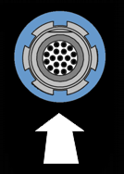 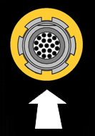

#### MDU

In the event that an MDU is detected the control module first determines if the MDU is capable of hand control. If the MDU is not capable of hand control then a footswitch must be used to control the MDU. If determined that the MDU is capable of hand control the control module will constantly monitor the status of the hand controls. Second, the control module determines if the connected MDU supports blade recognition, if it does the blade type is continuously monitored. The control module notifies the GUI module that an MDU has been detected and in turn the GUI module will display the required data and widgets on the appropriate side of the screen as follows:

Port A Port B

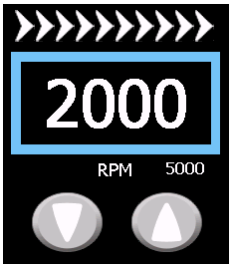 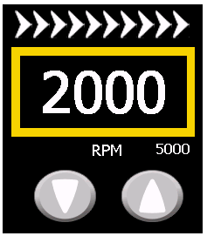

Note that each port contains direction indicators, Set Speed value, color coded outline around the Set Speed box, unit of measure, maximum range, decrement adjustment button and an increment adjustment button. Default Set Speeds and maximum range is determined by the DYONICS POWER MDU Table below.

1. All modes of operation are displayed via large directional indicators representing Forward, Reverse, Oscillate or Window Lock. When an MDU’s current mode of operation is set to Oscillate the oscillate direction indicators OscillateDirectionOff are displayed in white on the appropriate side of the screen. If the Forward mode of operation is selected the control module will notify the GUI module who in turn displays the forward direction indicators ForwardDirectionOn in green, on the appropriate side of the screen. When the MDU is turned off, the control module will notify the GUI module who in turn displays the forward direction indicators  in white, on the appropriate side of the screen. If the Reverse mode of operation is selected the control module will notify the GUI module who in turn displays the reverse direction indicators ReverseDirectionOn in green, on the appropriate side of the screen. When the MDU is turned off, the control module will notify the GUI module who in turn displays the reverse direction indicators ReverseDirectionOff in white, on the appropriate side of the screen. If the Oscillate mode of operation is selected the control module will notify the GUI module who in turn displays the oscillate direction indicators OscillateDirectionOn in green, on the appropriate side of the screen. When the MDU is turned off, the control module will notify the GUI module who in turn displays the oscillate direction indicators OscillateDirectionOff in white, on the appropriate side of the screen. If Window Lock mode of operation is selected the control module will notify the GUI module who in turn displays the Window Lock direction indicators WindowLockDirectionOn in green, on the appropriate side of the screen. When the MDU is turned off, the control module will restore the prior mode of operation and will notify the GUI module who in turn displays the restored mode operation’s direction indicators in white, on the appropriate side of the screen. Note, The Green direction indicators represent a % of full Set Speed (in 10% increments for Forward and Reverse, and 20% increments for Oscillate mode of operation) therefore if the MDU is running at 80% of Set Speed, the direction indicators will be displayed as 8 arrows in green and 2 arrows in white.
2. If an MDU is detected in Port A the GUI is notified by the control module and will display the Set Speed box  with a Set Speed value and a blue outline, on the appropriate side of the screen. If an MDU is detected in Port B the GUI is notified by the control module and will display the Set Speed box  with a Set Speed value and a yellow outline, on the appropriate side of the screen. **NOTE:** The values of the Set Speeds may differ than as shown. The initial Set Speed is determined by the selection of Blade Default/Blade Recall mode which is user configurable in the Settings menu. If the mode is set to Default then default values are initialized otherwise saved values are initialized. After the initial setup of the display the Set Speed will vary depending on the mode of operation being utilized. The Set Speed for Forward, Reverse and Oscillate Mode 1 will be displayed as RPM values. The Set Speed for Oscillate Mode 2 will be displayed as RATE values (1-9).
3. If an MDU is detected the GUI is notified by the control module and will display the maximum RPM or the Unit of Measure, depending on the current MDU mode of operation. The information is displayed below and to the right of the Set Speed Box mentioned in 2.2.4.1 b, on the appropriate side of the screen. If the current mode of operation is Forward or Reverse the maximum RPM is displayed. If the current mode of operation is Oscillate Mode 1 the unit of measure which is RPM is displayed. If the current mode of operation is Oscillate Mode 2 the unit of measure which is RATE is displayed.
4. If determined that a handpiece is in a running state the GUI will be notified by the control module and will display the green direction indicators, depending on what the current mode of operation is, on the appropriate side of the screen. Also, the GUI changes the background color of the Set Speed box from black to green. If the handpiece is turned off the background color of the Set Speed box will return to black.
5. Set Speed can be an RPM or RATE adjustment. Forward Reverse and Oscillate Mode 1 are always RPM adjustments. Oscillate Mode 2 is a RATE adjustment. Set Speed values can be adjusted within a range of numeric values. The values are adjusted by pressing the increment BtnArrowUp or decrement BtnArrowDown adjustment buttons. When the Set Speed has reached the minimum range the decrement button will disappear. When the Set Speed has reached the maximum range the increment button will disappear. When the Set Speed is not at the minimum or maximum range both buttons will be present. The control module is notified by the GUI module of a change in Set Speed which in turn changes the speed of a powered MDU. Forward, Reverse and Oscillate Mode 1 unit of measure is in RPM and can be adjusted in increments of 100. Oscillate Mode 2 unit of measure is in RATE with a range of 1 - 9 in increments of 1.
6. For the ability to adjust RPM for forward and reverse modes refer to section e above.
7. The ability to auto scroll the RPM or RATE is provided by holding down increment/decrement adjustment. The increment/decrement adjustment will occur automatically at a fixed repeat rate if either button is held down for a second or more. Auto scrolling will cease when the adjustment button is released or when the Set Speed has reached its minimum or maximum range. Refer to section e for details RPM or RATE adjustment.
8. If an MDU that supports blade recognition is connected the control module will continuously monitor the blade status as mentioned above. If a blade change occurs the control module will notify the GUI module and a new set of ranges will be used and the Maximum range box will be updated.
9. The DYONICS POWER II MDU Table below lists all of the MDUs that are supported by the DYONICS POWER II Control System. The DYONICS POWER II MDU Table shows their forward, reverse and oscillate ranges and default setting per blade magnet configuration.

**DYONICS POWER II MDU Table**

| **MDU Type** | **Magnets** | **Forward** | | **Reverse** | | **Oscillate Mode 1** | | **Oscillate Mode 2** | |
| --- | --- | --- | --- | --- | --- | --- | --- | --- | --- |
| **Range** | **Default** | **Range** | **Default** | **Range** | **Default** | **Range** | **Default** |
| Mini-Motor: **7205357** | None | 100-3500 | 2000 | 100-3500 | 2000 | 500-3000 | 1000 | N/A | N/A |
| DYONICS PowerMax Elite:  **72200616, 72200617, 72200872, 72202546** | Left | 100-3000 | 2000 | 100-3000 | 2000 | 500-3000 | 2000 | 1-9 (1 Rev)  1-8 (2 Rev) | 9 (1 Rev)  8 (2 Rev) |
| None | 100-5000 | 2000 | 100-5000 | 2000 | 500-3000 | 2000 | 1-9 (1 Rev)  1-8 (2 Rev) | 9 (1 Rev)  8 (2 Rev) |
| Right | 500-8000 | 4000 | 500-8000 | 4000 | 500-3000 | 2000 | 1-9 | 9 |
| Both | 500-10000 | 5000 | 500-10000 | 5000 | 500-3000 | 2000 | 1-9 | 9 |
| DYONICS POWERMINI  **72201500, 72201503** | 0S | 100-3000 | 2000 | 100-3000 | 2000 | 500-3000 | 3000 | 1-8 | 8 |
| 00 | 100-5000 | 3500 | 100-5000 | 3500 | 500-3000 | 3000 | 1-9 | 9 |
| 0N | 500-6000 | 6000 | 500-6000 | 6000 | 500-3000 | 3000 | 1-9 | 9 |
| N0\* |  |  |  |  |  |  |  |  |
| S0\* |  |  |  |  |  |  |  |  |
| NN\* |  |  |  |  |  |  |  |  |
| SN\* |  |  |  |  |  |  |  |  |
| NS\* |  |  |  |  |  |  |  |  |
| SS\* |  |  |  |  |  |  |  |  |

Note: Defaults and Ranges are determined by the MDU model along with blade type if the MDU supports blade recognition. To determine Magnet configuration, hold the blade assembly with the blade pointing away from you and rotate the base until the latching key is on top.1 Rev or 2 Rev indicates the Mode 2 Revolutions setting.

\* - Reserved for future development, system reports Port Warning PW2.

1. If an MDU is detected and supports Oscillate Mode 2 a button will be provided to toggle between Oscillate Mode 1 and 2 and will appear at the bottom of the appropriate side of the screen for Port A or Port B. The button looks as follows TempDeltaMode and will appear only after one of the 2 oscillate modes are activated and the MDU is NOT activated.
2. When an MDU with a 3 button hand control is first detected the current mode of operation is set to Oscillate by default. If the forward hand control button is pressed the control module places the MDU in the Forward mode of operation. If any of the button controls on the MDU are now pressed the MDU will be turned off by the control module. If the reverse hand control button is pressed the control module places the MDU in the Reverse mode of operation. If any of the button controls on the MDU are now pressed the MDU will be turned off by the control module. If the oscillate hand control button is pressed the control module places the MDU in the Oscillate mode of operation. If any of the button controls on the MDU are now pressed the MDU will be turned off by the control module. If the oscillate hand control button is pressed and held down for a second or more the control module places the MDU in the Window Lock mode of operation. If the oscillate button control is released the control module will turn off the MDU and restore the mode of operation to the prior Oscillate. If the forward hand control button is held down for a second or more the Set Speed will alternate between two speeds while displaying the forward direction indicators ForwardDirectionOn in green, on the appropriate side of the screen. Both Set Speeds are adjusted by pressing the adjustment buttons while continuing to hold down the forward button. A release of the forward button will leave the Set Speed in the last Set Speed value. If the reverse hand control button is held down for a second or more the Set Speed will alternate between two speeds while displaying the reverse direction indicators ReverseDirectionOn in green, on the appropriate side of the screen. Both Set Speeds are adjusted by pressing the adjustment buttons while continuing to hold down the reverse button. A release of the reverse button will leave the Set Speed in the last Set Speed value.  
   When an MDU with a 2 button hand control is first detected the current mode of operation is set to Oscillate by default. When the distal hand control button is pressed the control module places the MDU in the Forward mode of operation. The distal hand control button must be released within 1 second to remain in the Forward mode of operation. If either of the button controls on the MDU is pressed the MDU will be turned off by the control module and after notification the GUI will display the forward direction indicators in white, on the appropriate side of the screen. If the distal hand control button is pressed and held for a second or more the control module places the MDU in the Reverse mode of operation. If either of the button controls on the MDU is pressed the MDU will be turned off by the control module. If the proximal hand control button is pressed the control module places the MDU in the Oscillate mode of operation. The proximal control button must be released within 1 second to remain in the Oscillate mode of operation. If either of the button controls on the MDU is pressed the MDU will be turned off by the control. If the proximal hand control button is pressed and held down for a second or more the control module places the MDU in the Window Lock mode of operation. When the proximal button control is released the control module will turn off the MDU and restore the mode of operation to the prior Oscillate. Pressing the distal control button has no effect while the MDU is operating in the Window Lock mode of operation.
3. When an MDU without hand control is first detected the current mode of operation is set to Oscillate by default and the Oscillate direction indicators OscillateDirectionOff are displayed in white on the appropriate side of the screen. The control module checks that a footswitch is present and assigned to MDU. If a footswitch is found the control module route commands from the footswitch to the assigned MDU. If a footswitch is either not detected or not assigned to an MDU without hand controls the control module notifies the GUI to update the display with Footswitch Required.
4. The DYONICS POWER II provides an expandable 485 interface that permits the support of additional of MDUs and up to 9 different blade families per MDU.
5. When an MDU is connected to the DYONICS POWER II, a Window Lock button  will appear on the on the lower left hand side of the screen for Port A or the lower right hand side of the screen for Port B. The Window Lock button is provided to set the Window Lock position and is serviced on a first come first serve basis. Pressing the Window Lock button sets the operating mode of an assigned MDU to Window Lock. Releasing the Window Lock restores the prior operating mode of the MDU.

#### Powered Instrument

In the event that a powered instrument is detected, the control module will constantly monitor the status of the hand controls to determine if the handpiece supports direction control. If a drill is capable of direction control the control module supports forward and reverse mode of operation while a drill that is not capable of direction has only forward mode of operation support. A saw indicates oscillate mode of operation. A combo indicates forward mode of operation. The control module notifies the GUI module that a Drill, Saw or Combo has been detected and in turn the GUI module will display the required data and widgets on the appropriate side of the screen as follows:

Port A Drill Port B Saw Port A Combo

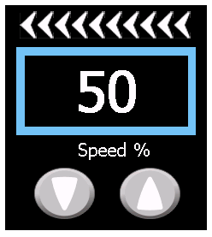 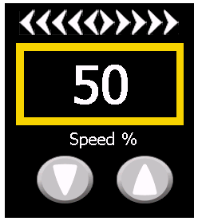 

Note that each port contains direction indicators, % of full speed value, color coded outline around the % of full speed box, decrement adjustment button and an increment adjustment button.

1. All modes of operation are displayed via large directional indicators representing forward, reverse, or oscillate. When a Trigger is used for activation of the Powered Instrument, the actual speed will be variable and determined by the amount of depression of the Trigger, (in the range of stopped when released to the % of full speed value when fully depressed). If a saw is detected the control module will notify the GUI module who in turn displays the oscillate direction indicators OscillateDirectionOff in white, on the appropriate side of the screen. If the saw is activated the control module will notify the GUI module who in turn displays the oscillate direction indicators OscillateDirectionOn in green, on the appropriate side of the screen. If the saw is de-activated the control module will notify the GUI module who in turn displays the oscillate direction indicators OscillateDirectionOff in white, on the appropriate side of the screen. If a drill is detected and it does not support direction, control the mode of operation is set to forward only. If a drill is not activated and in the forward mode of operation the control module will notify the GUI module who in turn displays the forward direction indicators ForwardDirectionOff2 in white, on the appropriate side of the screen. If the drill is activated while in the forward mode of operation the control module will notify the GUI module who in turn displays the forward direction indicators ForwardDirectionOn in green, on the appropriate side of the screen. If a drill is detected and it supports direction, control the control module will continuously monitor the status of the direction control. If the direction control is set to the reverse mode of operation the control module will notify the GUI module who in turn displays the reverse direction indicators ReverseDirectionOff in white, on the appropriate side of the screen. If the drill is activated while in the reverse mode of operation, the control module will notify the GUI module who in turn displays the reverse direction indicators ReverseDirectionOn in green, on the appropriate side of the screen. Note, The Green direction indicators represent a % of full Set Speed therefore if the Powered Instrument is running at 80% Set Speed the direction indicators will be displayed as 8 arrows in green and 2 arrows in white.
2. If determined that a handpiece is activated the GUI will be notified by the control module and will display the green direction indicators, depending on what the current mode of operation is, on the appropriate side of the screen. In addition, the GUI changes the background color of the % of full speed box from black to green. If the handpiece is de-activated, the background color for the % of full speed box will return to black.
3. If a powered instrument is detected in Port A the GUI is notified by the control module and will display the % of full speed box  with a % of full speed value and a blue outline, on the appropriate side of the screen. If a powered instrument is detected in Port B the GUI is notified by the control module and will display the % of full speed box  with a % of full speed value and a yellow outline, on the appropriate side of the screen. NOTE: The values of the % of full speed may differ than as shown. The initial % of full speed is determined by the selection of Blade Default/Blade Recall mode which is user configurable in the Settings menu. If the mode is set to Blade Default then default values are initialized otherwise saved values are initialized. The default value is 50 % of full speed for a drill and 100% of full speed for a saw.
4. A % of full speed value can be adjusted within a range of numeric values. The values are adjusted by pressing the increment BtnArrowUp or decrement BtnArrowDown adjustment buttons. When the % of full speed has reached the minimum range the decrement button will disappear. When the % of full speed has reached the maximum range the increment button will disappear. When the % of full speed is not at the minimum or maximum range both buttons will be present. The control module is notified by the GUI module of a change in % of full speed which in turn changes the speed of a powered instrument. The % of full speed range is 10 – 100 in increments of 10 percent.
5. The ability to auto scroll the % of full power is provided by the increment/decrement adjustment buttons. The increment/decrement adjustment will happen automatically at a fixed repeat rate if either button is held down. Auto scrolling will cease when the adjustment button is released or when the % of full speed has reached its minimum or maximum range.
6. The DYONICS POWER Powered Instrument Table below lists all of the Powered Instruments that are supported by the DYONICS POWER II Control System.

|  |  |  |
| --- | --- | --- |
| **DYONICS POWER Powered Instrument Table** | | |
| **Ref #** | **Description** |  |
| 7205785\* | Pistol Grip Drill Handpiece |  |
| 7205786\* | Inline Sagittal Saw Handpiece |  |
| 7205788 | Power Cable | (connects handpieces to control unit) |
| \*requires REF 7205788 | | |

#### Oscillate Modes

##### Mode 1

When the current mode of operation is set to Oscillate Mode 1, if an MDU is detected in either port the control module will notify the GUI module who in turn will display the text “Mode 1” directly under the Set Speed on the appropriate side of the screen.

##### Mode 2

When the current mode of operation is set to Oscillate Mode 2, if an MDU is detected in either port the control module will notify the GUI module who in turn will display the text “Mode 2” directly under the RATE on the appropriate side of the screen.

#### Footswitch

1. If a footswitch is detected the control module continuously monitors the status of the footswitch to detect pedal and button status. A footswitch can be mapped to either Port A or Port B and can be used to operate a handpiece. The mapping is user configurable in the Settings menus. The connected footswitch can control direction, speed and activate Window Lock mode of operation, which is serviced on a first come first serve basis. In the event of a state change, the control module notifies the GUI module who in turn displays the appropriate direction indicator status. Refer to section 2.2.4.1 and 2.2.4.2 for direction indicator protocol. In the case that a footswitch is connected and mapped to a port with an MDU that supports hand controls and Hand Control Override, which is user configurable in the Settings menus, is ON, the MDU hand controls are disabled allowing only for footswitch control of the MDU only. In the case that a footswitch is connected and mapped to a port with an MDU that supports hand controls and Hand Control Override is OFF the MDU hand controls or the footswitch can control the MDU on a first come first serve basis. Pedal depressions are acknowledged on a first come first serve basis. Depression of a pedal or button after another pedal depression or button press has been acknowledged results in the latter depression being ignored, with the exception of a Digital On/OFF Footswitch which depression of the Forward and Reverse pedals results in activation of Oscillate Mode. In the case that a footswitch is connected and mapped to a port with a Powered Instrument connected the footswitch or the Powered Instrument trigger control can control the Powered Instrument on a first come first serve basis, allowing one or the other to control the device at any given time. The state of Hand Control Override configurable in the Settings menus is ignored when Powered Instruments are connected.
2. If a connected footswitch supports lavage control and a press of the button occurs the control module will transmit the command to a connected DYONICS 25 Fluid Management System or to the INTELLIO Link interface.
3. The DYONICS POWER II Footswitch Table below lists all of the footswitches that are supported by the DYONICS POWER II Control System.

|  |  |
| --- | --- |
| **DYONICS POWER II Footswitch Table** | |
| **Ref #** | **Description** |
| 7205396 | Smith & Nephew DYONICS POWER Footswitch, pedal-style, on/off |
| 72201092 | DYONICS POWER II Footswitch |

1. The DYONICS POWER II Footswitch (Ref # 72201092) communicates with the Application using the DYONICS II RS485 Accessory Protocol (15000286) and its behavior is specified in the DYONICS II Footswitch Software Requirements Specification (15000283).
2. If a connected footswitch supports Speed Up/Down buttons, pressing the Speed Up button will increase the Set Speed and pressing the Speed Down button will decrease the Set Speed of the assigned Handpiece using the same criteria as the Set Speed increment/decrement adjustment buttons on the screen. The Speed Up button is ignored if the Set Speed increment adjustment button is not displayed on the screen. The Speed Down button is ignored if the Set Speed decrement adjustment button is not displayed on the screen.
3. If a connected footswitch supports Window Lock button pressing the Window Lock sets the operating mode of an assigned MDU to Window Lock. Releasing the Window Lock restores the prior operating mode of the MDU. The state of the Window Lock button is ignored when the footswitch is assigned to a Powered Instrument.

#### Warnings / Faults

There are 4 different types of warning displays. One consists of a single line message, another consists of a detailed popup message a third consists of a system popup warning message and the fourth is a fatal Black Screen message. The control module continuously monitors status and checks for possible warning/error situations and will notify the GUI module if and when a warning/error condition occurs. A warning condition can be a system warning or a specific port warning. Also, certain warning/error conditions warrant the sounding of a beeper. The control module will continuously turn the beeper on for 500ms ±5% then off for 500ms ±5% until the condition goes away. See TABLE 1, 2 and 3 for beeper details.

1. Upon notification from the control module of certain warning conditions the GUI module will display a single line message on the appropriate side of the screen, as follows:

Example Single Line Warning Port A Example Single Line Warning Port B

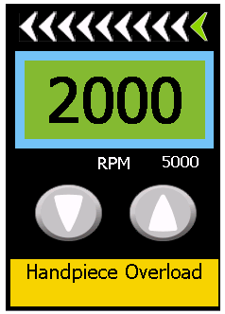 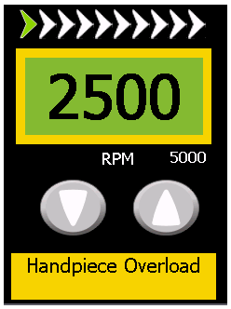

1. Upon notification of a warning condition from the control module the GUI module displays a single line message describing the warning condition. See table 1, Short Warning Message.
2. Upon notification of a warning condition from the control module the GUI module displays a single line message in a box with a yellow background and black text WarningShort.
3. If the yellow single line message is touched by the user via touch screen the GUI module will display a detailed popup message fully describing the warning condition as follows:

Example of detailed popup message

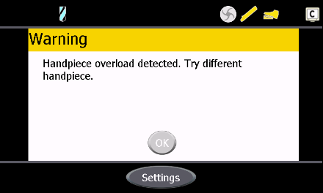

Refer to Table 1, Detailed Warning Message

1. In the event that a detailed popup message box is launched, the state of the OK button in the message box is continuously monitored by the framework. If a press of the OK button occurs the message box is closed.
2. The control module will reduce functionality of a handpiece in the event of a warning/error condition if warranted. See TABLE 1, Action.
3. Upon notification of a system warning from the control module the GUI module will display a system warning popup box describing the warning in detail. The state of the OK button in the popup box is continuously monitored by the GUI module. If a press of the OK button occurs the message box is closed. See TABLE 2. Example of system warning popup message below:

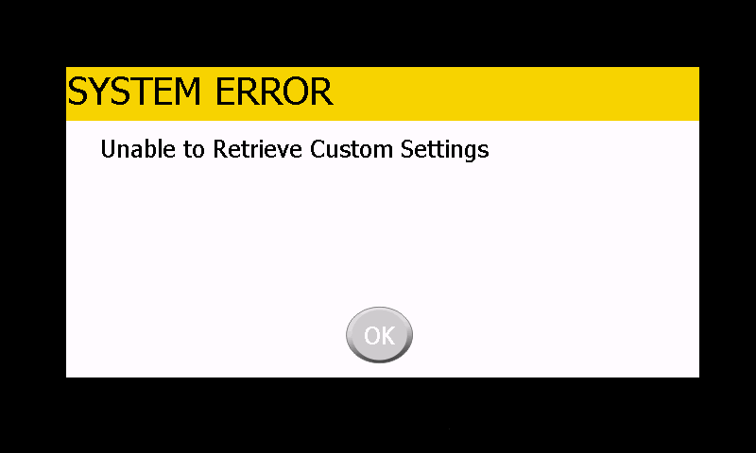

1. Upon notification of a fatal error from the control module the GUI module will shut down all motors and launch a black screen which will contain the fatal error number. For the Communications Failure FE2 a hard reset is applied to the Motor Controller from the System Controller to guarantee that that all motors are shut down. See TABLE 3. Example of black screen:

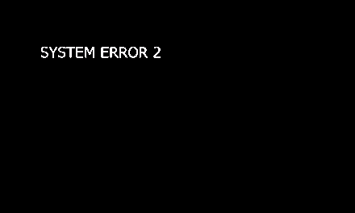

**Port Warning Message Table**

| **ID** | **Port Warnings** | **0.5s Beep** | **Action** | **Short Warning Message** | **Detailed Warning Message** |
| --- | --- | --- | --- | --- | --- |
| PW1 | Temperature Limit Failure | Yes | Display warning in both port A/B status windows until condition goes away. | TEMPERATURE-LIMIT | Unit overheating. Check for blocked ventilation. Check fans. |
| PW2 | Unknown Blade ID Port A/B | No | Default to curved blade family. | Unknown Blade | Blade type not supported for connected handpiece. Handpiece is operating in Safe Mode. |
| PW3 | Unknown Handpiece ID Port A/B | No | Handpiece will not be allowed to operate. | Unknown Handpiece | Handpiece not recognized/supported. Try a different handpiece. |
| PW4 | Hall Bus Pattern Faults Port A/B | No | Configure motor for lowest common denominator | Handpiece Sensor Fault | Handpiece sensor fault. Handpiece is operating in Safe Mode. |
| No | While running if handpiece controls lost > 0.1 seconds display warning.  While running if handpiece controls lost >= 0.5 seconds shut motor down. Display warning and disable hand controls until handpiece is unplugged. |
| PW5 | Motor A/B Stall | Yes | If stall >= 3 seconds display warning until condition goes away. If stall >= 6 seconds display warning and shut motor down.  Motor Stall + Current limit indicates handpiece fault. | Blade Stall | Handpiece or blade is stalled. Stop the handpiece and check the blade. |
| PW6 | Yes | Motor Stall only indicates electrical problem | Handpiece Stall | Handpiece motor not running. Try a different handpiece. |
| PW7 | Motor A/B Tac Fault | Yes | Shut down Motor. | Handpiece Motor Fault | Try other port. If problem persists try a different handpiece. |
| PW8 | Motor A/B Short Circuit | Yes | Motor is shut down by Motor Controller | Short Circuit Detected | Handpiece or port short circuit detected. Try a different handpiece. If problem persists return unit for repair. |
| PW9 | Reserved for future use |  |  |  |  |
| PW10 | Motor A/B Current Limit | Yes | Limit fault >= 10 seconds display warning until condition goes away. | Handpiece Overload | Handpiece overload detected. |
| PW11 | Motor A/B Current Limit Timeout | Yes | Limit fault >= 60 seconds display warning and shut motor down. | Handpiece Overload Timeout | Handpiece overload detected. Try a different handpiece. |
| PW12 | Handpiece button down detected | Yes | Display warning in port status window until error goes away. | Handpiece Error | Check handpiece for depressed buttons. If none present try a different handpiece. |
| PW13 | Unknown Footswitch ID | Yes | Footswitch Icon will not appear, Display warning until error goes away. Footswitch not allowed to operate. | Unknown Footswitch | Unable to communicate with footswitch. Try a different footswitch. |
| PW14 | Footswitch Pedal Down when device detected | Yes | Display warning in port status window until error goes away. Icon will not appear until error goes away. | Footswitch Error | Check footswitch for depressed pedals or switches. If none present try a different footswitch. |
| PW15 | Wireless Footswitch Battery Low | Yes | Beep when critical low battery level reached. | Footswitch Battery Low | Recharge the wireless footswitch battery. |
| PW16 | Footswitch Required | No | Display warning in port status window until error goes away. | Footswitch Required | Handpiece does not have hand controls and requires a footswitch. |

**Popup Warning Message Table**

|  |  |  |
| --- | --- | --- |
| **ID** | **System Warnings** | **Text to Display** |
| PU1 | Unable To Save to non-volatile RAM | Unable to Save Custom Settings |
| PU2 | Unable to Save to Flash | Unable to Save Set Speeds |
| PU3 | Unable to Retrieve non-volatile RAM settings | Unable to Retrieve Custom Settings |
| PU4 | Unable to Retrieve Flash settings | Unable to Retrieve Set Speeds |

**Fatal Error Table**

|  |  |  |  |
| --- | --- | --- | --- |
| **ID** | **System Errors** | **Flat line Beep** | **Text to Display** |
| FE1 | System Failure | Yes | SYSTEM ERROR 1 (RESERVED: Not used at this time) |
| FE2 | Communications Failure | Yes | SYSTEM ERROR 2 |
| FE3 | Watch Dog Timer Event | Yes | SYSTEM ERROR 3 |
| FE4 | Resource Allocation Failure | Yes | SYSTEM ERROR 4 |

### Settings Screens

The application provides a mechanism for the user to configure supported control parameters. Pressing the SETTINGS button in the operational screen will launch the following screen:

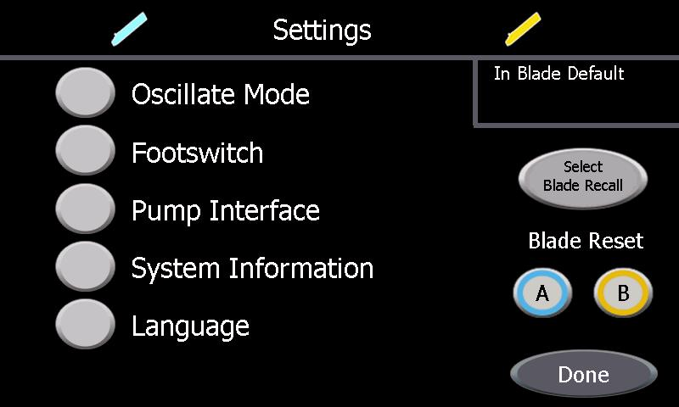

The Settings Menus permit the user to configure Oscillation Mode Settings, Footswitch settings, Pump Interface settings, Language selection and view System Information. A Mode select button is provided to allow the user to select the Blade Recall Mode or Blade Default Mode. The Blade Reset text and Blade Reset Port A and/or Port B buttons are present only when a handpiece is detected in that Port. If the user changes any of the supported parameters the changes will be automatically saved into battery backed up non-volatile RAM by the control module. The GUI module is notified by the framework of a button press and in turn will launch the appropriate screen or perform the appropriate task. A press of the DONE button will return to the previous operational screen. The following table shows the initial configuration of the settings found in the Settings screen:

**DEFAULT SETTINGS TABLE**

|  |  |  |  |
| --- | --- | --- | --- |
| **(Settings Screens)** | **Default** | | |
| **Oscillate Mode** |  | **Port A** | **Port B** |
| **Current Mode** | **Mode 1** | **Mode 1** |
| **Mode 1 – Seconds** | **0.30** | **0.30** |
| **Mode 2 – Revolutions** | **2** | **2** |
| **Footswitch** | **Mode** | **Variable** | |
| **Port Control** | **Port A** | |
| **Hand Control Override** | **On** | |
| **Forward** | **R** | |
| **Pump Interface** | **Port Control** | **Port A** | |
| **Language** | **English** | | |

Many of the Settings Screens use a selection box. A selection box is a boxed in area of the screen that has two buttons where one is “solid” with black text and the other is “hollow” with white text. A selection box is used to select a single option or mode for a given function where only one option can be chosen at a time. The button that is solid is the currently selected option. Pressing the “hollow” button will cause the button to become solid and be the currently select option while the previous button will become “hollow”.

#### Blade Reset

A press of the Port A or Port B Blade Reset button restores RPM, RATE, and % of full speed for all modes of operation depending on what handpiece is connected at the time of the button press. Port A button resets only Port A and Port B button resets only ort B.

#### Blade Recall / Blade Default Mode

1. A button is provided to select Blade Recall or Blade Default mode of operation. The button, if pressed, will toggle between Blade Recall and Blade Default modes. The GUI module will display text in the upper right hand side of the screen signifying the currently selected mode. The initial factory default is set to Blade Recall mode.
2. If Blade Recall mode is selected the GUI module will notify the control module who in turn will save into non-volatile FLASH the last settings of oscillate, forward, reverse or % of full speed initially and whenever the values change thereafter, for Port A and/or Port B.
3. If an MDU that supports blade recognition is detected the forward, reverse and oscillate Set Speeds will be saved into non-volatile FLASH and recalled on a per blade basis.
4. During system power up the control module checks the state of Blade Recall/Blade Default mode of operation. If Blade Recall mode was the last saved state in the battery backed up non-volatile RAM the control module will initialize the Set Speeds parameters with the last saved values from non-volatile FLASH for Port A and/or Port B, if a handpiece is found. The GUI module will request these parameters from the control module and use these values during the initial creation of Port A and/or Port B if a handpiece is found.
5. During system power up the control module checks the state of Blade Recall/Blade Default mode of operation. If Blade Default mode was the last saved state in the battery backed up non-volatile RAM the control module will initialize the Set Speeds parameters with the default values for Port A and/or Port B, if a handpiece is found. The GUI module will request these parameters from the control module and use these values during the initial creation of Port A and/or Port B if a handpiece is found.
6. If a handpiece is connected after system power up the control module checks the state of Blade Recall/Blade Default mode of operation. If Blade Recall mode was the last saved state in the battery backed up non-volatile RAM the control module will initialize the Set Speeds parameters with the last saved values from non-volatile FLASH for Port A and/or Port B. The GUI module will request these parameters from the control module after notification of a newly detected handpiece and use these values during the initial creation of Port A and/or Port B.
7. If a handpiece is connected after system power up the control module checks the state of Blade Recall/Blade Default mode of operation. If Blade Default mode was the last saved state in the battery backed up non-volatile RAM, the control module will retain the Set Speeds parameters with the current values for Port A and/or Port B. Default values are only instantiated at power up.

#### Oscillate Modes

Pressing the OSCILLATE MODE button from the Settings screen will launch the following screen:

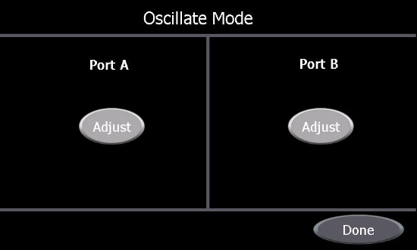

The user can customize the currently activated Oscillate Mode. A press of the DONE button will return to the Settings screen along with notifying the control module of the user selected mode.

1. The oscillate default mode is Oscillate Mode 1 which is the optimized mode.
2. See section 2.2.4.1 j

##### Mode 1

A press of the adjust button for either port from the Oscillate Mode Screen will launch the following screen if Oscillate Mode 1 activated:

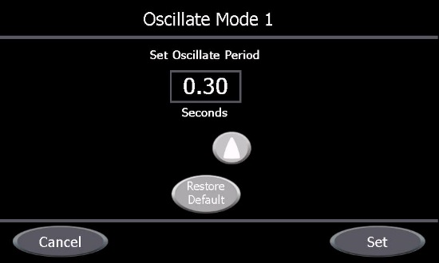

The “Seconds” adjustment is the number of seconds it takes for one forward / reverse period of oscillation. The time is adjusted in increments of 0.1 seconds by pressing the increment BtnArrowUp or decrement BtnArrowDown adjustment buttons. The range of the adjustment is 0.30 to 1.0 seconds. When the time has reached the minimum range the decrement button will disappear. When the time has reached the maximum range the increment button will disappear. When the time is not at the minimum or maximum range both buttons will be present. A press of the RESTORE DEFAULT button will restore the seconds setting to a default value of 0.3. A press of the CANCEL button returns to the previous screen. Pressing the SET button notifies the control module to save the current settings, to use the newly selected value, and returns to the previous screen

##### Mode 2

A press of the adjust button for either port from the Oscillate Mode Screen will launch the following screen if Oscillate Mode 2 is activated:

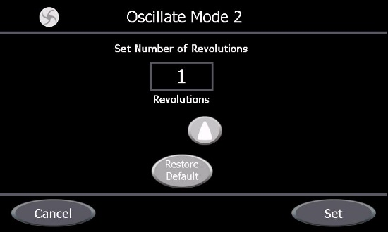

The “Revolutions” adjustment is the number of revolutions to rotate in each direction before reversal during oscillation. The number of revolutions is adjusted in increments of 1 revolution by pressing the increment BtnArrowUp or decrement BtnArrowDown adjustment buttons. The range of the adjustment is 1 to 2 revolutions. When the number of revolutions has reached the minimum range the decrement button will disappear. When the number of revolutions has reached the maximum range the increment button will disappear. When the number of revolutions is not at the minimum or maximum range both buttons will be present. A press of the RESTORE DEFAULT button will restore the number of revolutions setting to a default value of 2. A press of the CANCEL button returns to the previous screen. Pressing the SET button notifies the control module to save the current settings, to use the newly selected value, and returns to the previous screen.

#### Footswitch

Pressing the FOOTSWITCH button from the Settings screen will launch the following screen:

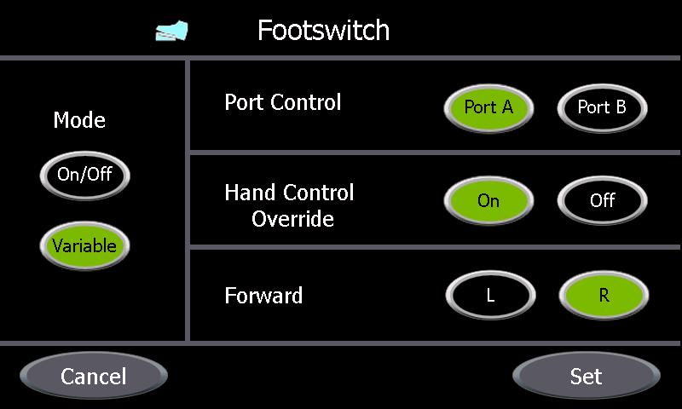

The Footswitch Menu permits the user to configure the way the footswitch works. The GUI module is notified by the framework of a button press and in turn will perform the appropriate task. A press of the CANCEL button returns to the previous screen. A press of the SET button notifies the control module to save the current settings, to use the newly selected settings, and returns to the previous screen.

1. When an analog footswitch is detected the footswitch is allowed to be configured in one of two modes, On/Off (digital) or Variable (analog). In the On/Off state a press of a foot pedal is fully on while a release of a foot pedal is fully off. In the Variable state the amount of pressure applied to the foot pedal determines the % of ON, similar to the way a gas pedal in a car works. Pressing the ON/OFF button selects digital mode while pressing the VARIABLE button selects the analog mode.
2. The footswitch can be mapped to either Port A or Port B. A press of the Port A button maps the footswitch to Port A while a press of the Port B button maps the footswitch to Port B.
3. Hand Control Override can be set to On or Off. A press of the Off button will allow a hand-controlled MDU and a footswitch connected and mapped to the same port as the MDU to control the MDU on a first come first serve basis. Only one source of control can be active at one time. A press of the Hand Control Override On button will override the hand-controls on a MDU when a footswitch is connected and mapped to the same port as the MDU. The Hand Control Override setting has no effect on a powered instrument.
4. When a footswitch that supports re-mapping of the forward and reverse pedals is detected the configuring of the Forward L/R selection will be allowed. A press of the L button will map the forward mode of operation to the Left foot pedal. A press of the R button will map the forward mode of operation to the right foot pedal.
5. Refer to section c for the mechanism for footswitch controls to override hand controls of an MDU.

#### Pump Interface

Pressing the PUMP INTERFACE button from the Settings screen will launch the following screen:

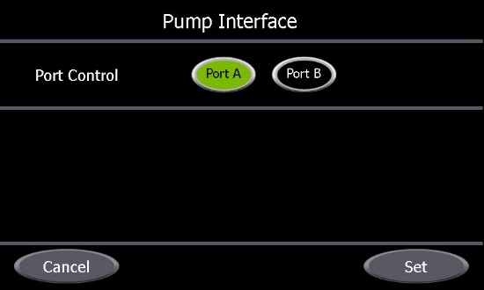

The Pump Interface Menu permits the user to select what port is to communicate with the DYONICS 25 Fluid Management System through the Shaver Pump Interface or with a pump connected through the INTELLIO Link Interface. The GUI module is notified by the framework of a button press and in turn will perform the appropriate task. A press of the Port A button will map the interface to Port A. A press of the Port B button will map the interface to Port B. A press of the CANCEL button returns to the previous screen. A press of the SET button notifies the control module to save the current settings, to use the newly selected setting, and returns to the previous screen.

#### System Information

Pressing the SYSTEM INFORMATION button from the Settings screen will launch the following screen:

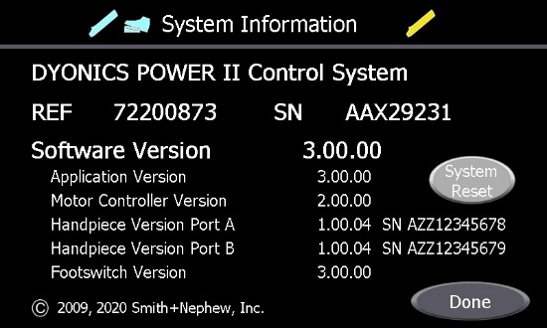

Versions and serial numbers shown in this view are for illustrative purposes only. A press of the DONE button will return to the previous screen.

1. The GUI module displays the Product name, Model Number, Serial Number, Software revision levels, and Smith+Nephew, Inc. Copyright.

* The Handpiece version number for Port A is only displayed when a device which supports the Dyonics II RS485 Accessory Protocol (15000286) (i.e. the PowerMini) is connected to Port A.
* The Handpiece serial number, up to 11 characters, for Port A is only displayed when a device which supports the Dyonics II RS485 Accessory Protocol (15000286) is connected to Port A.
* The Handpiece version number for Port B is only displayed when a device which supports the Dyonics II RS485 Accessory Protocol (15000286) (i.e. the PowerMini) is connected to Port B.
* The Handpiece serial number, up to 11 characters, for Port B is only displayed when a device which supports the Dyonics II RS485 Accessory Protocol (15000286) is connected to Port B.
* The Footswitch version number is only displayed when a DYONICS POWER II Footswitch is connected.

1. Upon a press of the System Reset button a confirmation popup screen will appear as shown below:

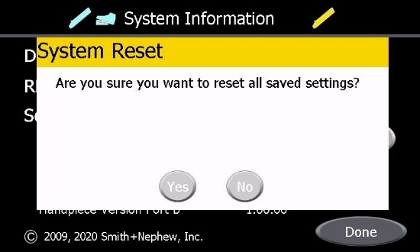

A press of the YES button will reset ALL saved settings. A press of the NO buttoncauses no action and will return to the System Information screen. All settings get reset with the exception of the language setting.

#### Language

Pressing the LANGUAGE button from the Settings screen will launch the following screen:

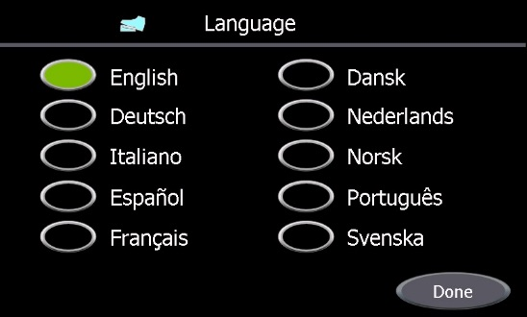

1. The GUI module will display a menu of supported languages. The preferred language can be selected by pressing the adjacent button. A press of the DONE button will return to the previous screen. Upon selection of a language a confirmation popup screen will appear as shown below:

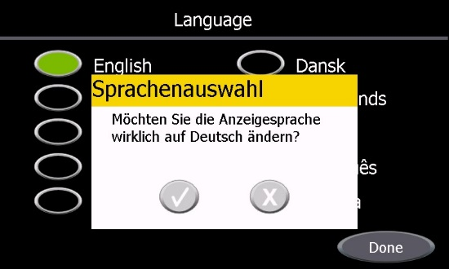

The popup text will be displayed in the language the user wants to change to. A press of the check mark button will notify the control module to save and invoke the currently selected language then return to the language screen. A press of the X buttoncauses no action and will return to the language screen.

### Board and System Tests

The Board Tests require the following hardware in order to complete the tests:

* Wireless Loopback Test Fixture – Ref # 20600619
* Pump Loopback Test Fixture Ref # - 91000270
* CONDOR Loopback Test Fixture Ref # - 91000269
* Handpiece / Footswitch Test Fixture – Ref # 20600579
* Mini-Motor MDU – Ref # 7205357
* PowerMax Elite MDU – Ref # 72200616
* PowerMini MDU – Ref # 72201500
* Drill – Ref # 7205785
* Pedal-Style, On/Off Footswitch – Ref # 7205396
* DYONICS POWER II Footswitch – Ref # 72201092

1. The Board Tests perform the following tests in order to verify proper SC and MC operation:
   * Power On Self Test

Verify that enough of the basic functions of the board work to continue with the rest of the tests. These include the SC / MC communication, SC memory, SC temperature and SC Watch Dog.

* + Non Volatile Ram Test

Verify that the battery backup of the Non Volatile Ram functions.

* + Serial Port Test

Verify that all three SC serial ports function.

* + Buzzer Test

Verify that the SC and MC buzzer controls function.

* + USB Test

Verify that both external USB ports function.

* + Display Test

Visually verify that the color LCD display is able to display all 15 bits of color.

* + Handpiece A Test

Verify that all lines that go to the Handpiece A port from the MC function.

* + Handpiece B Test

Verify that all lines that go to the Handpiece B port from the MC function.

* + Footswitch Test

Verify that all lines that go to the Front Footswitch port from the MC function.

* + Temperature Test

Verify that the MC and MCU temperature sensors function.

* + Power Button Test

Verify that Power Button is lit when the system is running and verify that that pressing the Power Button will power down the system.

1. For Board Tests, any failure will be displayed at the end of the test and the user will be prompted to acknowledge the failure by pressing the OK button. The Test List, on the left side of the screen, will show the PASS/FAIL status of each test. The Board Tests will give detailed failure messages (in the Handpiece/Footswitch tests) to help in trouble shooting the board in test.

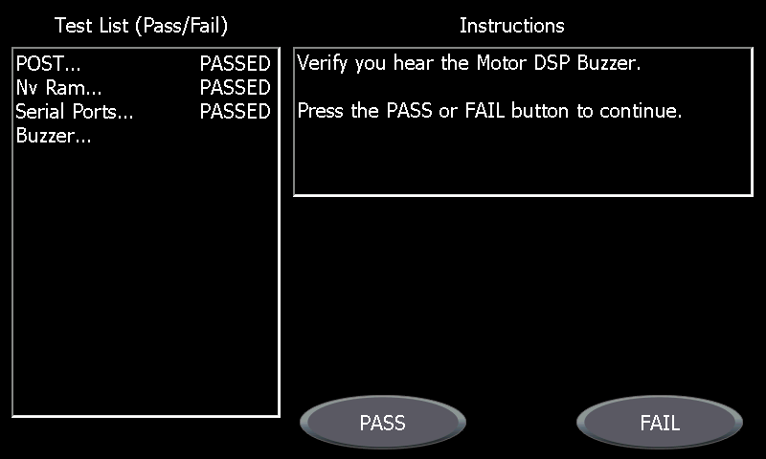

1. To enter Board Tests a Factory Mode USB key is inserted into one of the external USB ports and the system is powered on. Once system powers up and passes the Power On Self Test then following screen will be displayed:

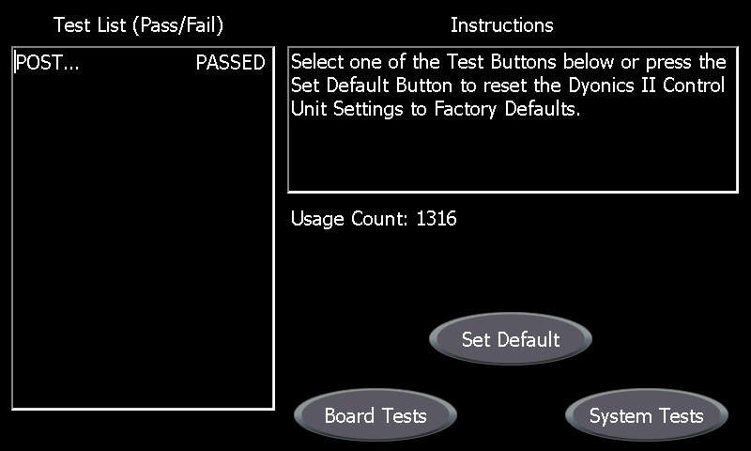

Pressing the BOARD TESTS button will execute the remaining Board Tests.

1. In order to verify proper hardware configuration and operation, the System Tests perform a Serial Number Test and a Touch Screen Test along with all of the above Board Tests except the Temperature Test.
   * Power On Self Test
   * Serial Number Test

Verify that a device serial number is present in non-volatile memory, or request the user to enter one.

* + Non Volatile Ram Test
  + Touch Screen Test

Verify the functionality of the touch screen by having the user press on a specified screen location continuously for at least 5 seconds using a stylus.

* + Serial Port Test
  + Buzzer Test
  + USB Test
  + Display Test
  + Handpiece A Test
  + Handpiece B Test
  + Footswitch Test
  + Power Button Test

1. For System Tests, any failure will be displayed at the end of the test and the user will be prompted to acknowledge the failure by pressing the OK button. The Test List, on the left side of the screen, will show the PASS/FAIL status of each test.

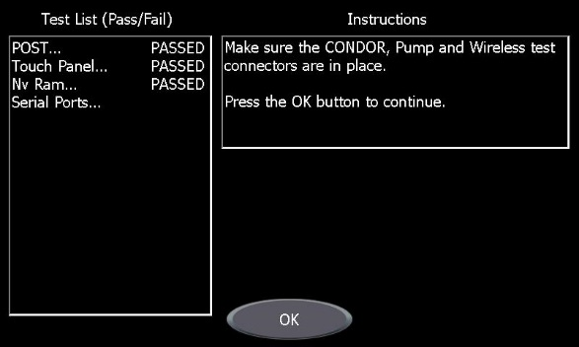

1. To enter System Tests a Factory Mode USB key is inserted into one of the external USB ports and the system is powered on. Once system powers up and passes the Power On Self Test then following screen will be displayed:



Pressing the SYSTEM TESTS button will execute the remaining System Tests.

1. Pressing the Set Default button resets the Settings to factory default.
2. Pressing the Repeat button will repeat a failed test.
3. Display the number of times a System has been powered on and a handpiece activated as the Usage Count.